SINGAPORE NAVY DISRUPTS SEA ROBBERY, 3 ARRESTED
POSTED: 01 Sep 2015 22:09
URL: http://www.channelnewsasia.com/news/singapore/singapore-navy-disrupts/2092660.html

The Republic of Singapore Navy worked with the Indonesian and Malaysian navies to apprehend the suspects, who had fled to Indonesian waters after sighting the RSN's RSS Resilience.

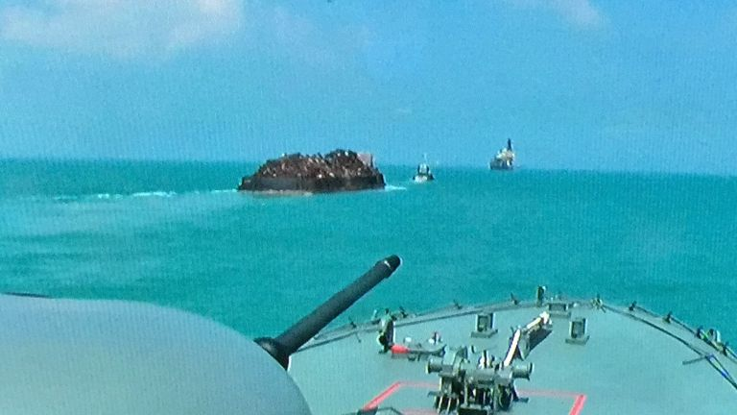
The RSS Resilience (foreground) escorting Permata 1 (centre) to Singapore waters following the successful disruption of the sea robbery. (Photo: MINDEF)

SINGAPORE: The Republic of Singapore Navy (RSN) disrupted a sea robbery on a Malaysian-flagged tugboat in the Singapore Strait on Tuesday (Sep 1).

In a press release, the Ministry of Defence (MINDEF) said that the Maritime and Port Authority of Singapore's Port Operations Control Centre had received a report from the boat, called Permata 1, at about 9am. Those on the boat had sighted robbers boarding their barge while they were transiting the eastern approaches of the Singapore Strait, MINDEF added.

The RSN's Maritime Security Task Force (MSTF) immediately deployed its Fearless-class patrol vessel the RSS Resilience, which arrived in the vicinity at about 9.20am. Upon seeing the warship, the robbers fled towards Indonesian waters, according to MINDEF.

The RSN's Information Fusion Centre (IFC) then shared information on the incident and suspects with the Indonesian Navy's (TNI AL) Western Fleet Sea Security Group, as well as the Malaysian Maritime Enforcement Agency, which deployed assets to assist in searching for the robbers. Through the description shared by IFC, the TNI AL successfully apprehended the three robbers and recovered the stolen cargo.

MINDEF stated that the RSS Resilience then accompanied Permata 1 safely to Singapore waters, where the Police Coast Guard boarded the tugboat for investigation.

“I am heartened to see the good cooperation between Singaporean, Indonesian and Malaysian enforcement agencies in disrupting the sea robbery attempt on Permata 1," said Rear-Admiral Frederick Chew, commander of the MSTF.

"In particular, the close cooperation between the RSN and TNI AL is a reflection of the strong ties between our navies. We need to continue working closely together to keep up the pressure on sea robbers and to bring sea robbery incidents down,” he added.

